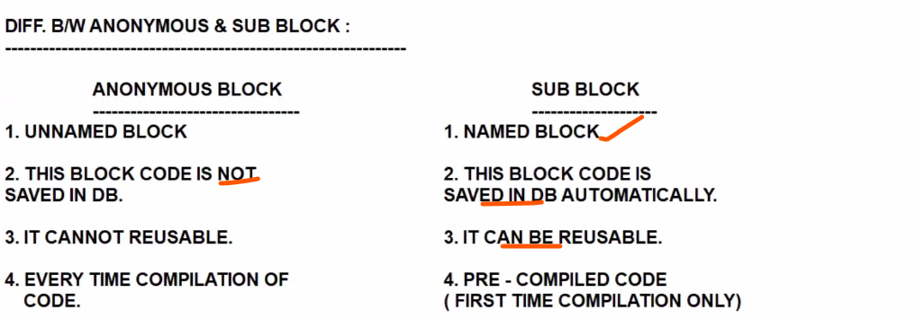

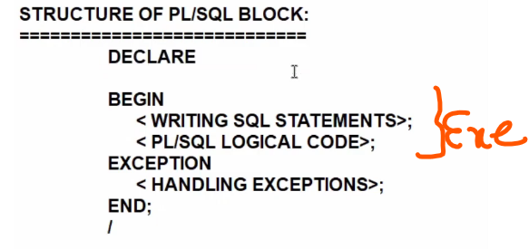

Declare
X varchar2 10;
Begin
X :=10
Dbms_output.line (x)
End ;

&takes a input in runtime.

DECLARE
x number(10);
y number(10);
z number(10);

BEGIN
x := &x;
y := &y;
z := x+y;
DBMS_OUTPUT.PUT_LINE(z);
END;
/

Select a,b in to x,y from emp where emp=1;

SET SERVEROUTPUT ON;
DECLARE
eemp number(10);
efirst_name varchar2(10);
BEGIN
SELECT employee_id, first_name INTO eemp, efirst_name FROM HR.employees WHERE ROWNUM = 1;
DBMS_OUTPUT.PUT_LINE('eemp '|| eemp || 'efirst ' || efirst_name);
END;
/

SELECT employee_id, first_name INTO eemp, efirst_name FROM HR.employees WHERE EMPLOYEE_ID = &EMPLOYEE_ID;

– if database table datatype change from varchar to date, plsql program associate variable i have to change. Otherwise mismatch works.

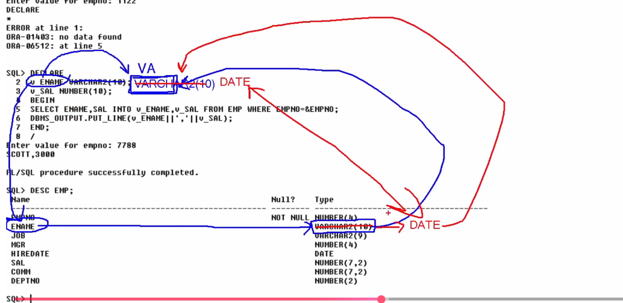

Automatically v ename datatype changes , advantages of anchor notations:

Column level
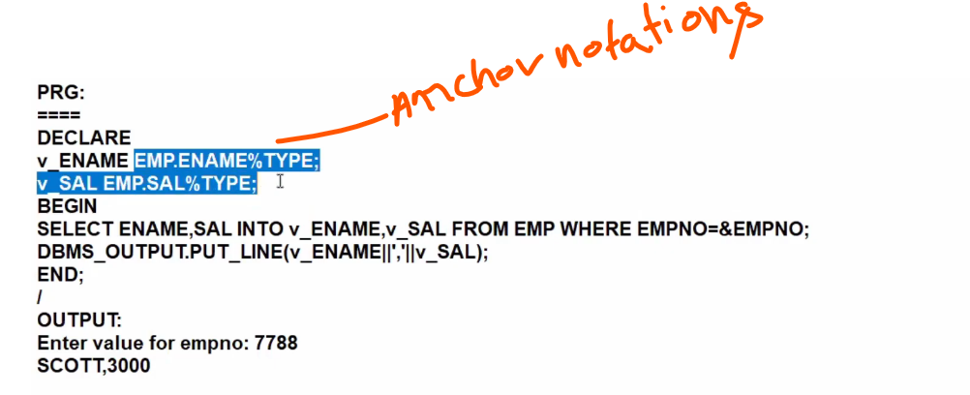

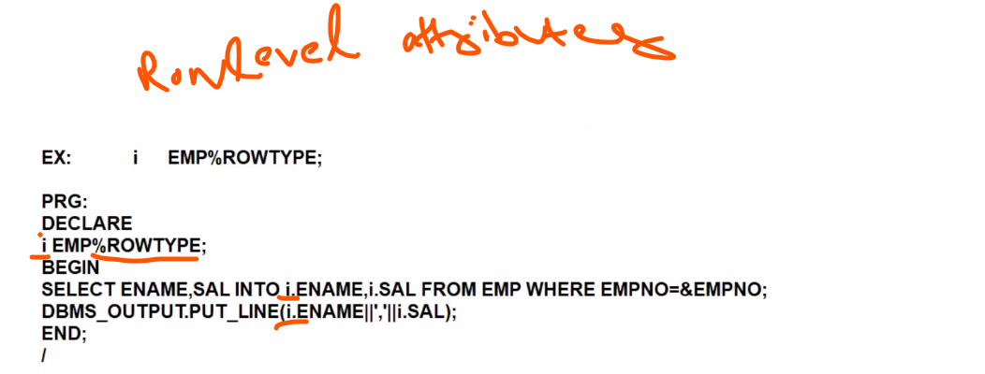

declare
vsal HR.employees.salary%type; —-> scalar variable
begin
select salary into vsal from hr.employees
where employee_id=100;
dbms_output.put_line('c1...' || (vsal));
end;

Implicit cursor:
Created by default when DML operations are performed.

To handle more than one row we use cursor or composite variable>

Cursor is rowlevel operation, if you want to fetch more than one row then its cursocr

Cursor Attributes:
Cursonrnameisopen
cursor_name%found
cursor_name%notfound
cursor_name%rowcount

Explicit Currosrs:

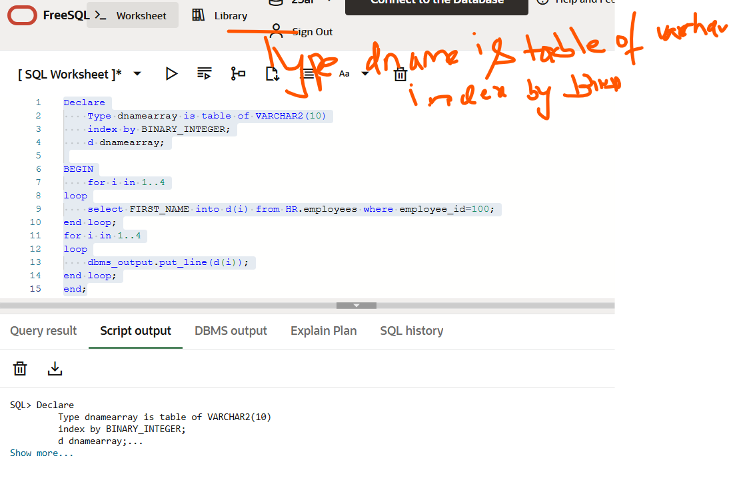
.++

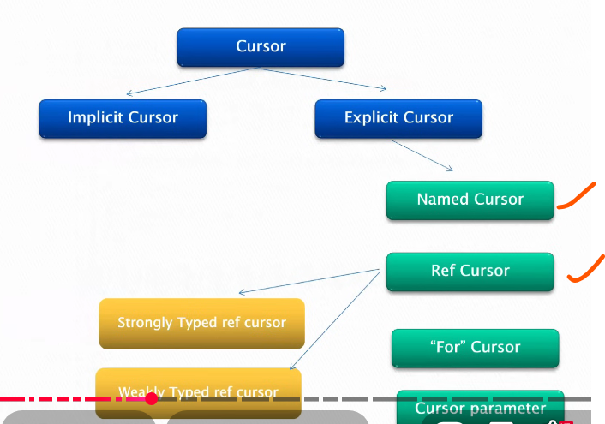

To handle many rows return from base table. More than one row,,, use cursors

Declare
OPEN
FETCH
CLOSE

Rowlevel operation, fetch more than one row go with cursor only.

C1 cursor
Is
Select empname inot c1 from hr.emplyue
Ftech c1 into vsal;
close

This will give you only first salary, you need to fetch one by one

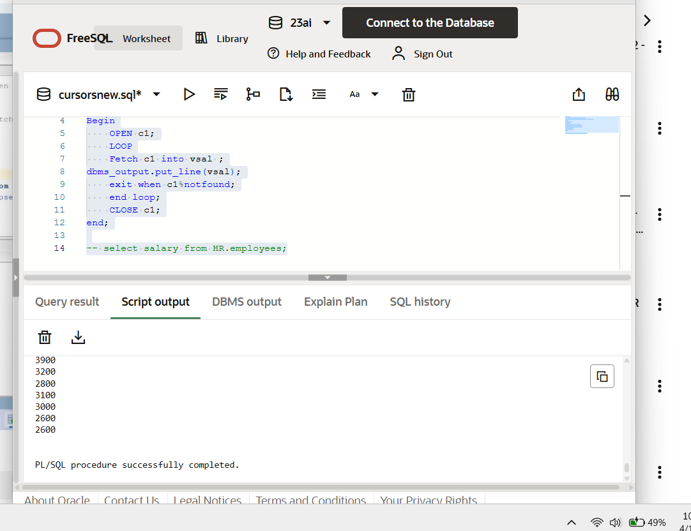

..
d dnamearray; → declare array variable
d(i) → access one value in that array

Peformance and logic issue

To overcome we used Bulk collect: fetch all elements from db and stored in dname
No of requests to db is reduced and performance is increased using Bulk collect.

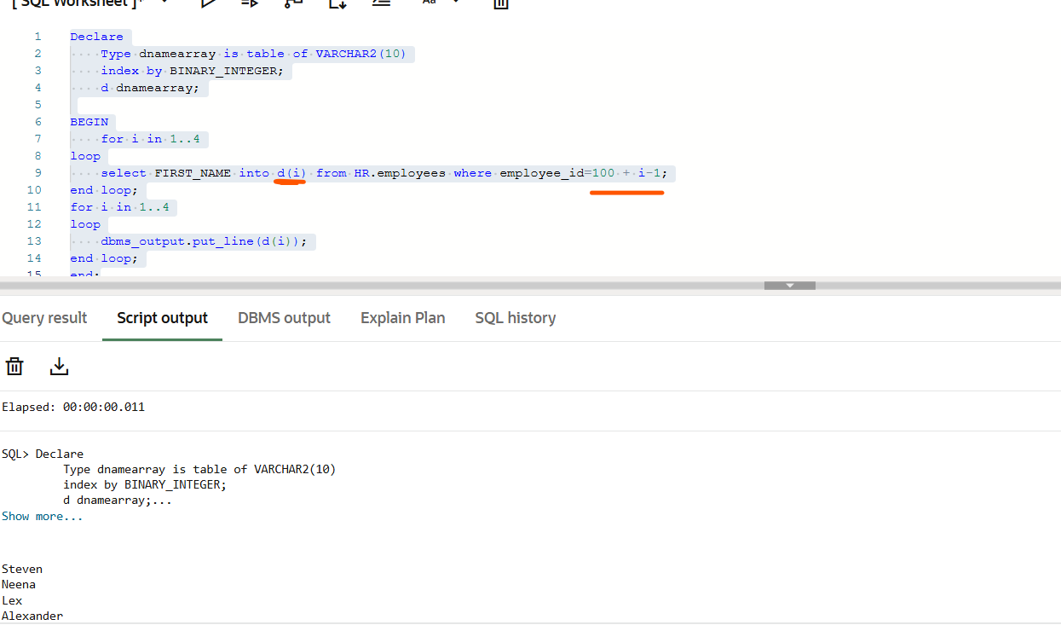

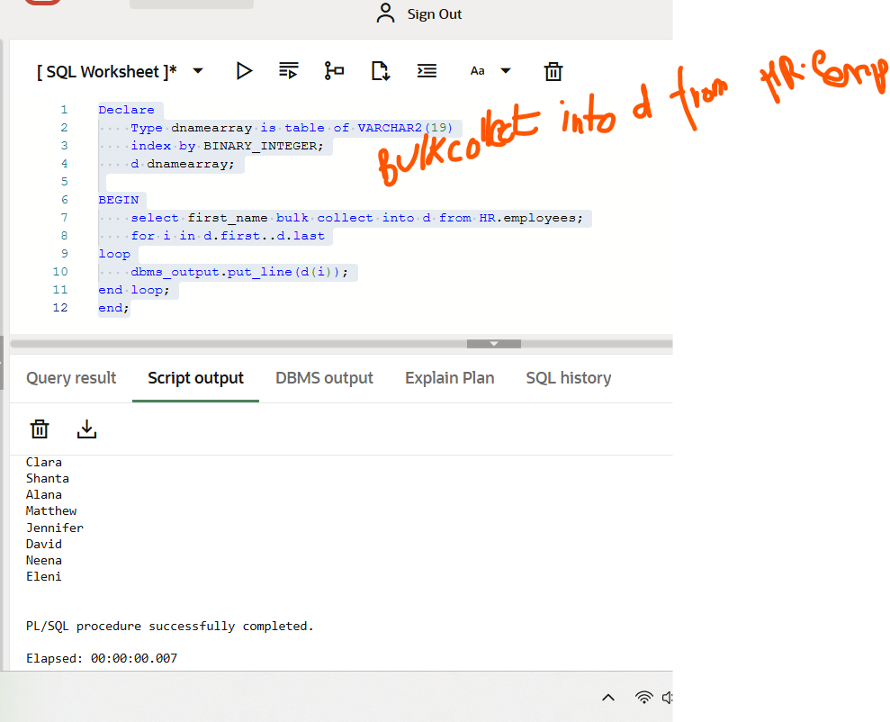

Dynamic sql:

Create or replace procedure drop_table
(t in varchar2, n in varchar2)
Is
Begin
Execute immediate ‘DROP ‘||t||’ ‘||n;
End;
/

STORD proceS:

create or replace procedure total_salary1 (inempid in number)
is
v_sal number(10);
begin
select salary + (salary * nvl(commission_pct,0)) into v_sal from employees_test
where employee_id = inempid;
dbms_output.put_line('vsalary: ' || v_sal);
end;
/
EXECUTE TOTAL_SALARY1 (100)

Cursor if we go for looping more data from base table.

Stored proc:
-- functions
create or replace function empfunc(v_emp_id number)
return number
is
vsalary number(10);
vnewsal number(10);
BEGIN
select salary into vsalary from EMPLOYEES_TEST where EMPLOYEE_ID=v_emp_id;
if (vsalary > 1000) THEN
vnewsal := vsalary+(vsalary *0.5);
else
vnewsal := vsalary+(vsalary *0.1);
end if;
return vnewsal;
end;
/

-- select * From EMPLOYEES_TEST
select EMPFUNC(100) from dual;

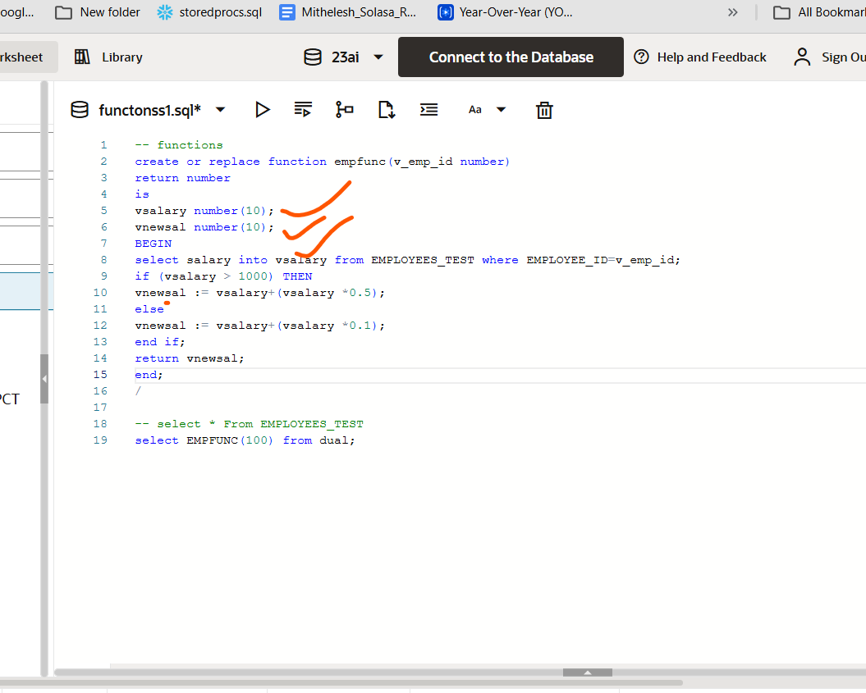

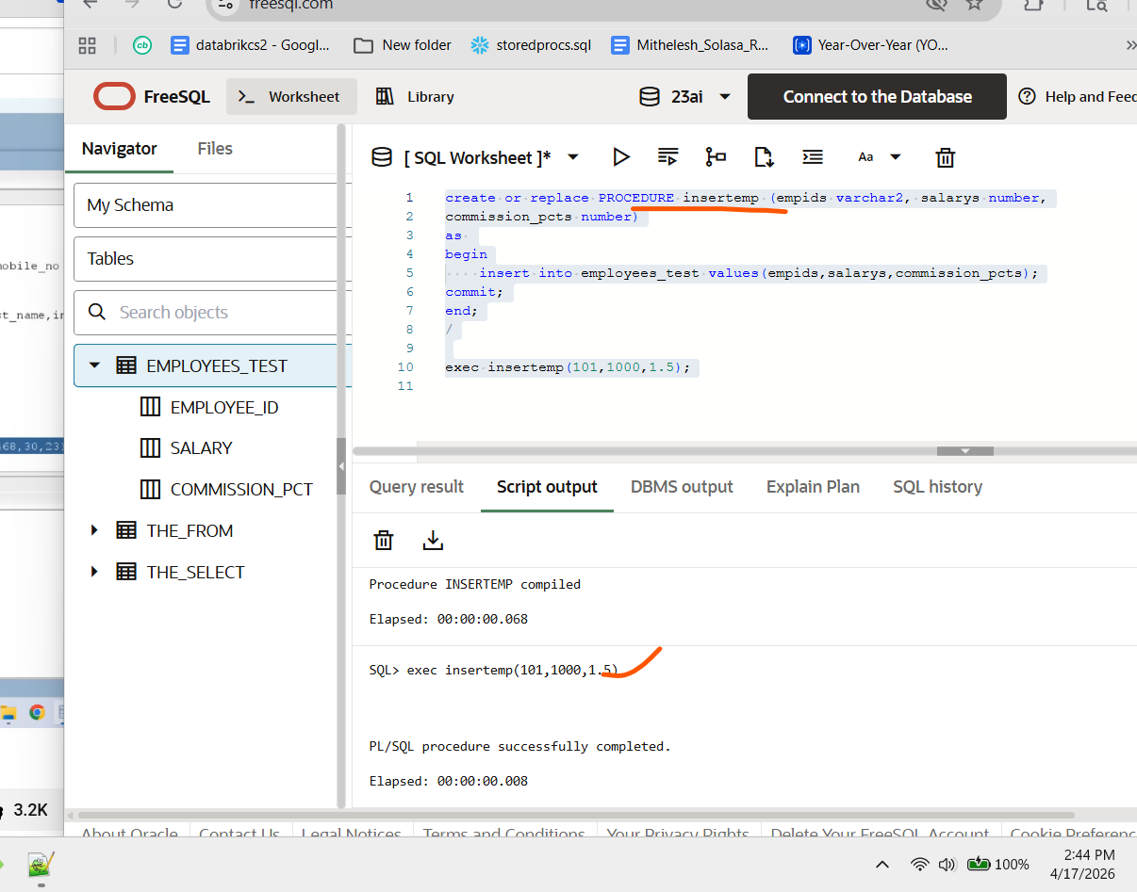

create or replace PROCEDURE insertemp (empids varchar2, salarys number,
commission_pcts number)
as
begin
insert into employees_test values(empids,salarys,commission_pcts);
commit;
end;
/

exec insertemp(101,1000,1.5);

Package:

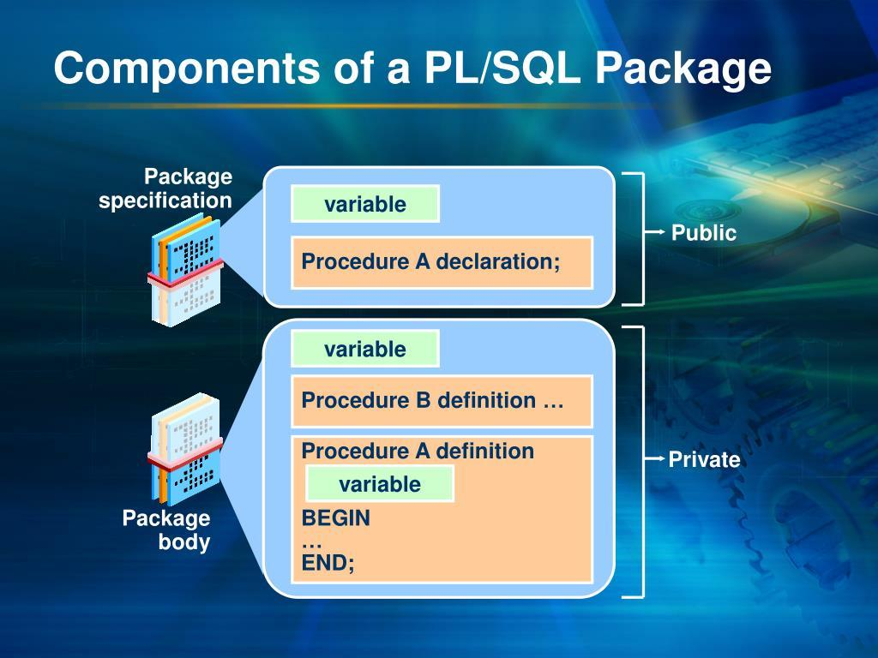

Create or replace package package_name as

Procedure totalsalary(empid number);
End package_name;
/

Create or replace package body pavkage_name as
Procedure totalsalary(empid number)
Is
V_salary number(10):
Begin

End totalsalary;
End package_body;

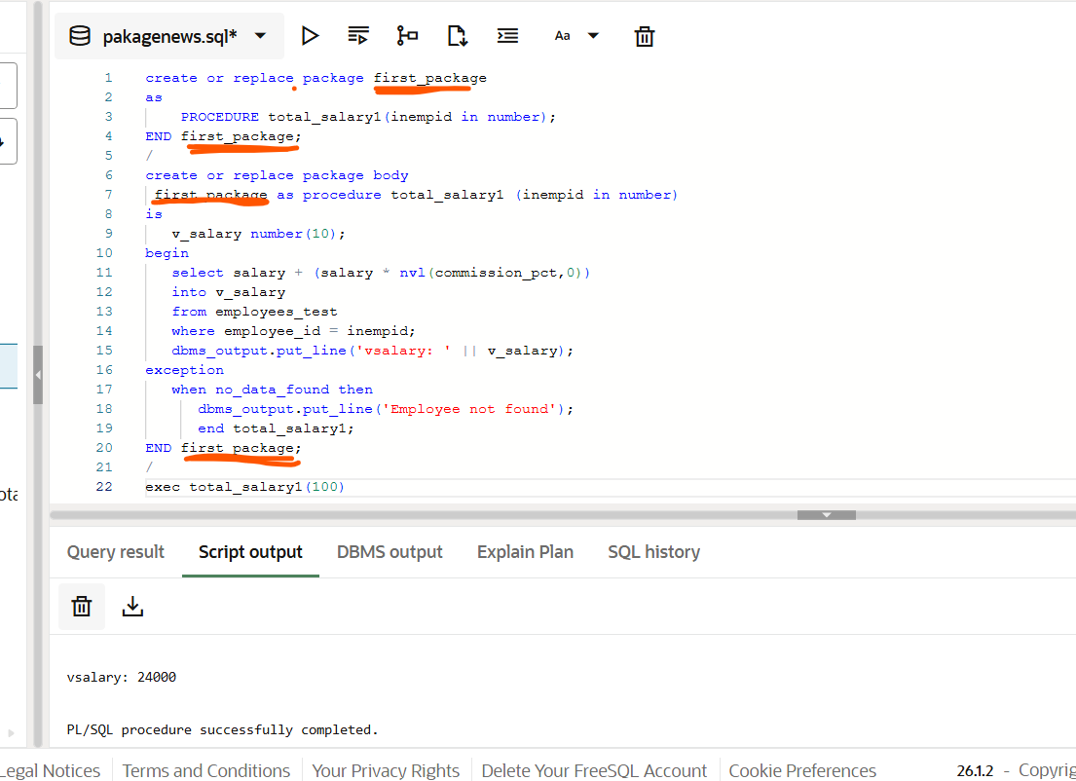

create or replace package first_package
as
PROCEDURE total_salary1(inempid in number);
END first_package;
/
create or replace package body
first_package as procedure total_salary1 (inempid in number)
is
v_salary number(10);
begin
select salary + (salary * nvl(commission_pct,0))
into v_salary
from employees_test
where employee_id = inempid;
dbms_output.put_line('vsalary: ' || v_salary);
exception
when no_data_found then
dbms_output.put_line('Employee not found');
end total_salary1;
END first_package;
/
exec total_salary1(100)

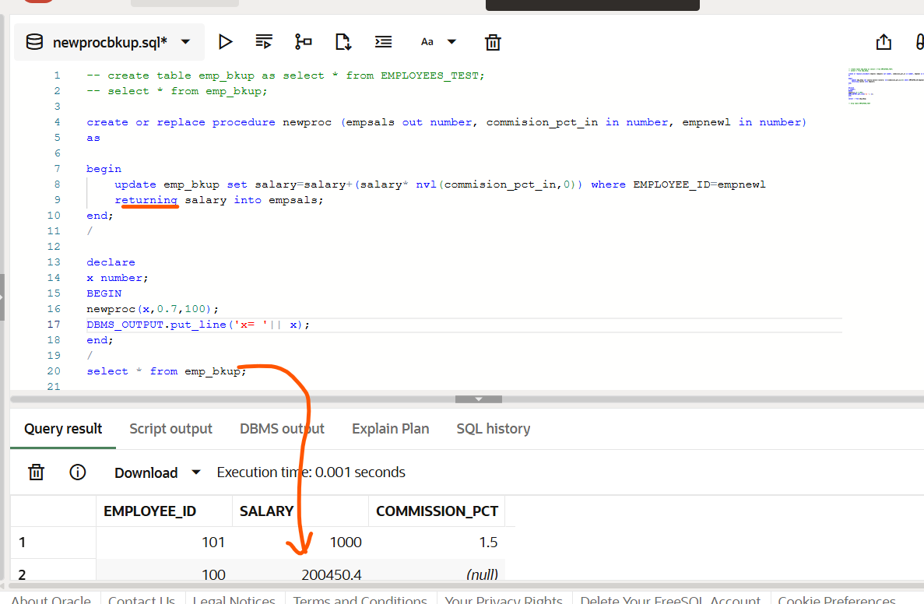

create or replace procedure newproc (empsals out number, commision_pct_in in number, empnewl in number)
as

begin
update emp_bkup set salary=salary+(salary* nvl(commision_pct_in,0)) where EMPLOYEE_ID=empnewl
returning salary into empsals;
end;s
/

declare
x number;
BEGIN
newproc(x,0.7,100);
DBMS_OUTPUT.put_line('x= '|| x);
end;
/
select * from emp_bkup;

Create or replace package sample_package_name as
Procedure procedure1;
Procedure procedure2;
End;

Create or replace package body sample_package_name as
Procedure procedure1 as
Begin
dbms_output.put_line(“ this is proc1”);
End;
Procedure procedure2 as
Begin
dbms_output.put_line(“ this is proc2”);
End;

Create or replace package sample_package_names as
Procedure procedure1;
Procedure procedure2;
End sample_package_names;
/

Create or replace package body sample_package_names as
Procedure procedure3 as
Begin
dbms_output.put_line(' this is proc3');
End procedure3;
Procedure procedure1 as
Begin
dbms_output.put_line(' this is proc1');
End procedure1;
Procedure procedure2 as
Begin
dbms_output.put_line('this is proc2');
procedure3;
end procedure2;
end sample_package_names;
/

begin
sample_package_names.procedure1;
sample_package_names.procedure2;
end;
/

Triggers:

Trigger is a special kind of stored proc that automatically executes when a event gets fired

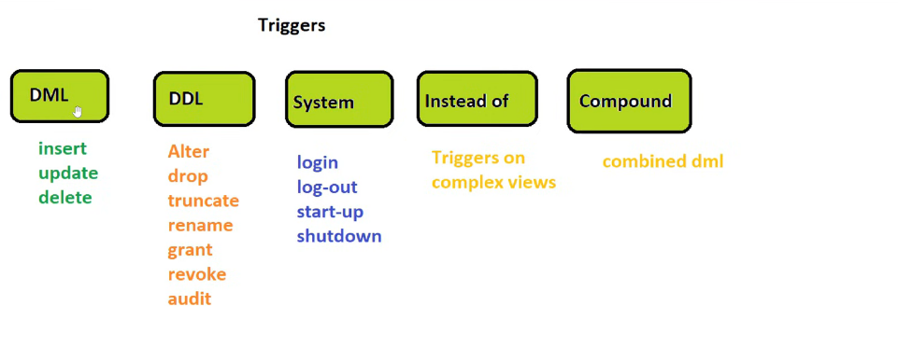

Complex views: you cannot do inserts or updates

Create or replace trigger trigger_name
Before insert /update/
On table_name
[For Each row] #

Declare
-– variable declarations
Begin

Exception
When
End;

-- 6. Create row-level delete trigger
CREATE OR REPLACE TRIGGER customer_trigger
BEFORE DELETE ON customerorg FOR EACH ROW
BEGIN INSERT INTO customer_bkp_trigger
VALUES (
:OLD.customer_id,
:OLD.first_name,
:OLD.mobile,
:OLD.address1,
:OLD.zipcode,
:OLD.country,
SYSDATE,
USER
);
END;
/

Collections:

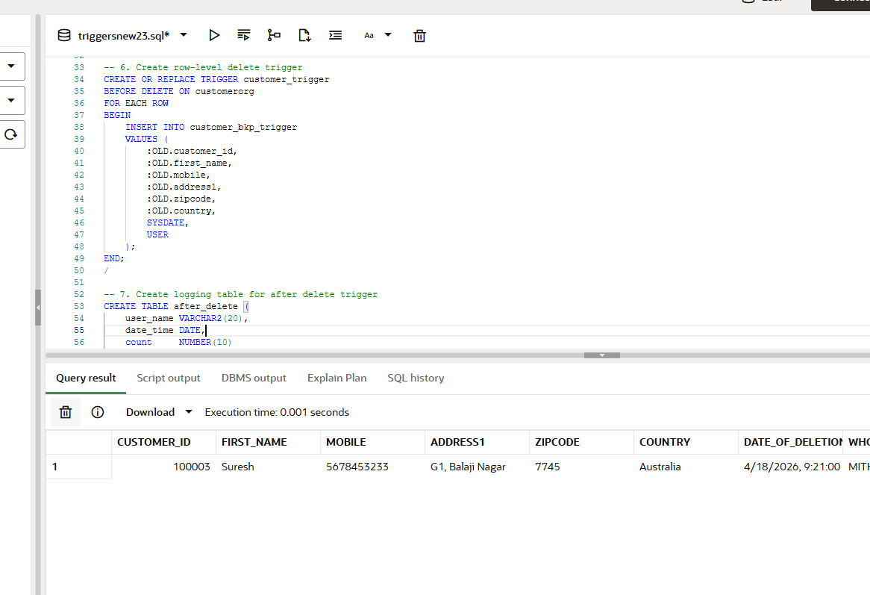

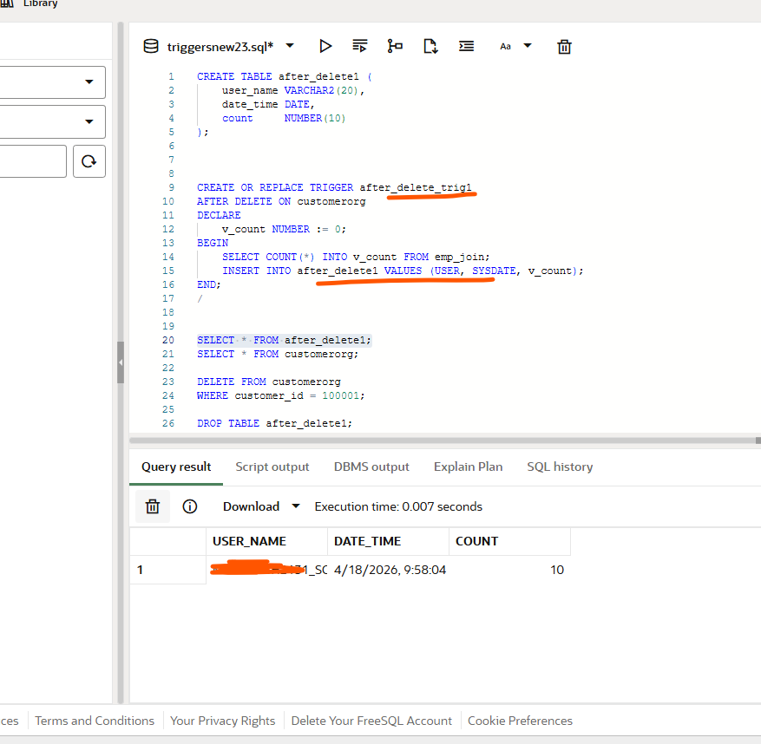

customer_trigger
- stores deleted row data
- row by row
- used for backup/audit of deleted records

after_delete_trig
- stores delete event info
- once per delete statement
- used for logging / post-delete actions

Collections:
BULK COLLECT SELECT that fetches multiple rows of data

FOR ALL ,Insert ,Update and Delete that use collections to change multiple rows of data.

Table Functions: functions that return collections and can be called in the FROM CLAUSE of select statements

A collection is a group of logically related elements.

Load all records in to local memory and perform operations on it and save it back to database.

Types of Collections:

VARRAY - Variable array– predefined size, index starts with elements
Nested –
Associate Array —Key value pair

—
Declare

Type V_array_type is varray(8) of varchar2(40):
V_color varraytype :=V_array_type(null,null,null,null,null,null,null,null)

Begin

address(1):=’02’
dbms_output.put_line
End;

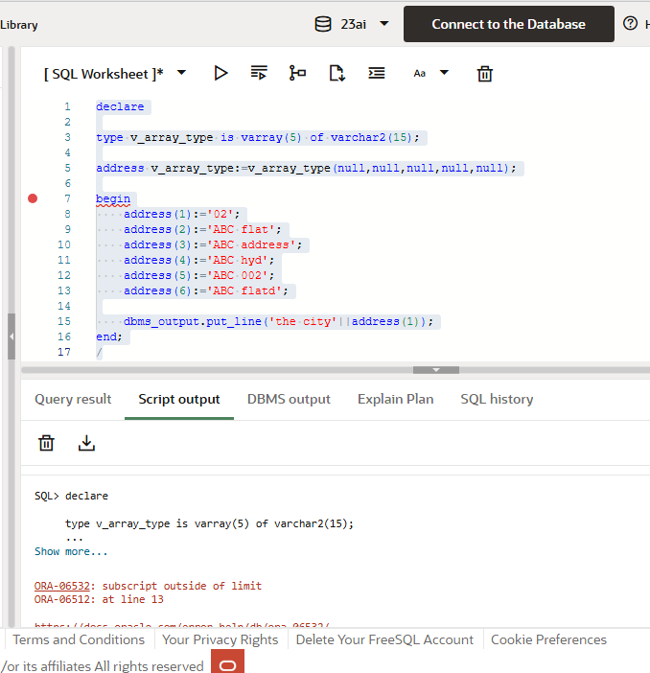’

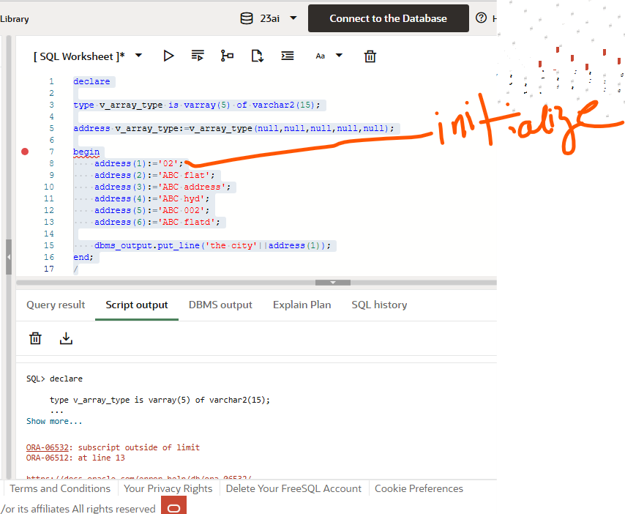

Limit
Collect
First
Last
Delete all elements
prior(n)
next(n)

